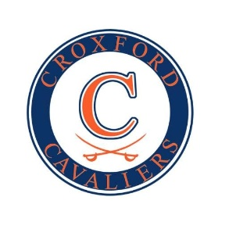

W.H. Croxford School Council

MEETING AGENDA

Monday, June 2, 2025, 6:00 PM

W.H. Croxford High School  
  
In attendance:  
Sarah Zagoda, Derek Keenan, Robin Ginter, Sarah Stilborn, Jon Stilborn, Meghen Buehmer, Nykol Kroeker, Tricia Lovegrove, Ivana Trodorovic.

1. Welcome and Call to Order   
   Call to order 6:00pm
2. Approval of Agenda   
   Approved 6:01 pm
3. Trustee Report – Todd Brand - unavailable
4. Administration Report
   1. Principal’s update - Derek Keenan
      1. Our School Survey – at 9% completion.

Grad 2025 review and 2026 planning (May 14, 2026)  
- Grad went very well due to larger venue. Sold over 2700 tickets. BMO Can hold 4000 people. YouTube Grad steam went very well also.  
Thursday May 14, 2026, is the grad date next year, will be at the BMO Center again.  
Prom went beautifully, no issues.  
Academy showcase is June 10th  
  
Will be annoucing honour roll in the Fall, as final grades are not in yet.

* + 1. Academy Showcase June 10
    2. Exam Period   
       Exams are coming up, it's in the Croxford Connection. Will be extended blocks to accommodate.
    3. Parking Passes – Survey has gone out in the Croxford connection to get spaces for next year.

1. Chair Update – AGM Council election
2. Adjournment at 6:17pm

AGM Council Election

Sarah Stilborn – Chair  
Ivana Trodorovic – Vice Chair  
Sarah Zagoda – Secretary   
  
Parent School Meetings for 25/26 will be:  
  
September 15 2025  
Oct 6 2025  
Nov 3 2025  
Dec 1 2025  
Feb 2 2026  
March 2 2026  
April 14 (Tuesday) 2026  
May 4 2026  
June 1 2026 AGM