Mathematics 9 Course Outline

Instructor: Ms. Johnston Email: njohnston@rockyview.ab.ca
njohnston@rvschools.ab.ca

Nature of the Course
The goals of this course are to have students gain an understanding and appreciation of the contributions of mathematics as a science, philosophy and art, as well as, gain a curiosity and positive attitude towards mathematics. Students will learn to engage in mathematical tasks and contribute to mathematical discussions. Each outcome requires that students develop a conceptual knowledge base and skill set that will be useful to their future endeavors. The topics covered within the course are meant to build upon previous knowledge and to progress from simple to more complex conceptual understandings.

Evaluation
Student report card marks are determined on the basis of class assignments, quizzes and outcome tests. The final report card mark is broken down below.

Course Schedule and Weights
Outcome 1 - Rational Numbers | 12%
Outcome 2 - Powers and Exponents | 12%
Outcome 3 - Polynomials | 12%
Outcome 4 - Surface Area | 9%
Outcome 5 - Circle Geometry | 9%
Outcome 6 - Similarity and Transformations | 9%
Outcome 7 - Linear Equations and Inequalities | 12%
Outcome 8 - Linear Relations | 12%
Outcome 9 - Probability and Statistics | 3%
Provincial Achievement Exam | 10%

- An assignment will be given in most classes. These questions are meant to provide practice of the concepts learned in class.
- There will be regular quizzes/assignments given (sometimes without notice) based on the homework assigned in class.
- Outcome exams will be given at the instructor’s discretion and will vary slightly in frequency and weight among the outcomes.
- Finally, there will be some unit projects given that summarize the concepts learned in each unit. Marks will be assigned based on the outcomes being addressed in the project.

Student Expectations

Preparation
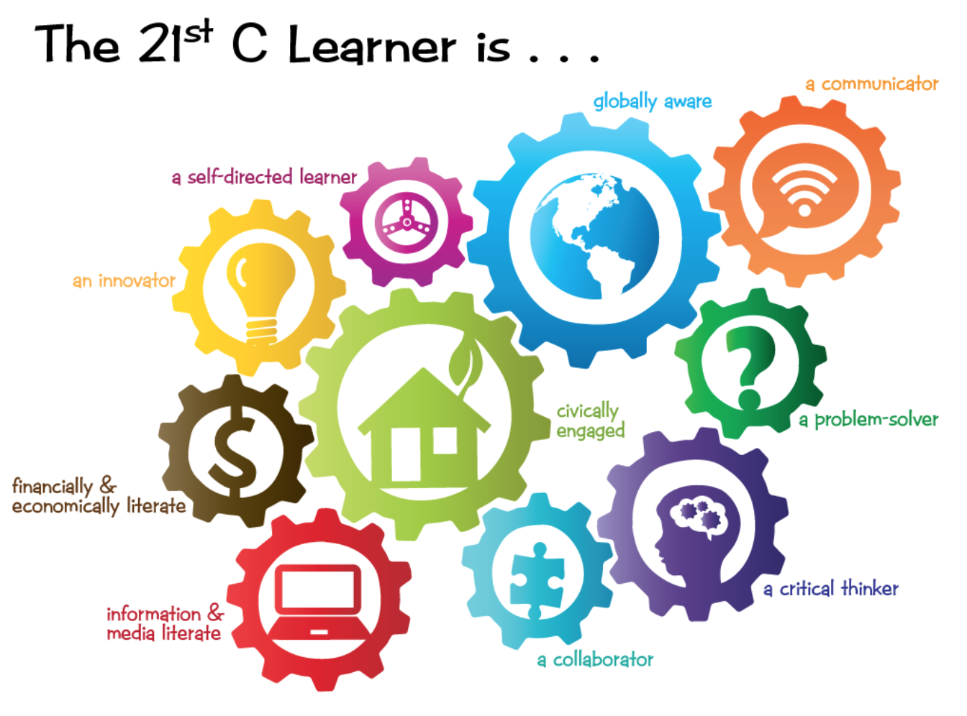
Come prepared to every class with all necessary supplies and materials:
- Math binder with lined paper and graph paper
- Pencil(s) and eraser, pen
- Scientific calculator (Your ipod or phone is NOT an acceptable calculator and not be permitted in ANY exams)
  - Not a graphing calculator. These are not permitted during the PAT exam.
- Personal Learning Device - As stated in the General Grade 9 Course Outline: “Students should bring a personal device that will support working and learning in this environment. Learning devices are NOT cell phones. A tablet or laptop are considered appropriate learning technologies. Devices should be charged, updated, and ready to use at the start of each day.”

Late Procedure
In order to maximize instructional time and limit disruption to the learning of others, students are expected to arrive in their classes prior to the late bell. Repeated lateness is disrespectful and discourteous and results in missed instruction. All lates will be reported on PowerSchool.

Absences
Given the nature of the course, time missed may seriously affect your overall success. Therefore, you are expected to attend all classes and to take responsibility for any work missed. If you know you are going to be absent, arrange to meet with your teacher in advance to get the work and material you will miss.
Students will be permitted to write a make-up test/quiz as long as it is within an appropriate time period, this will be at the teacher discretion. If the student cannot write a make-up test/quiz then the unit test or final exam mark may be substituted for the missed test/quiz, this is again at the teacher discretion.

If a student has missed an assignment due to an excused absence then that student will be given the assignment and permitted to hand in the assignment for marking without penalty at the teacher discretion.

Rewrites
Students are asked to do their best on an any assignment, including final projects and outcome exams. If a student receives a mark thy do not like, they may rewrite an exam or redo an assignment provided they fill out the retake form, have a discussion with the teacher, and reschedule another time in which they can complete the assessment.

Appeals

Students and parents may direct, in writing, any appeal of the final grade to the school Principal. (see the student handbook).

Extra Help
There are lots of resources for you to use online in Moodle. Resources range from PowerPoint presentations of notes and examples, videos of some of the examples done in class and links to other online resources.
ASK! If you are experiencing difficulties, do not wait until you are totally lost to get help. Ensure, however, that your effort during class time warrants extra help outside of class time.

